|  |  |  |
| --- | --- | --- |
| |  | | --- | | Admin |  |  | | --- | | User | |

* **User Panel:**

**If Click anyone go to Login Form**

* **Login Form:**

|  |  |  |
| --- | --- | --- |
| |  | | --- | | Admin |  |  | | --- | | User | |

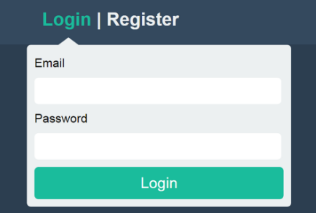

* **Register Form: If not a register user then need to registration.**

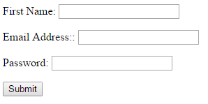

* **Admin Register User View Form:** After Admin login successfully it will show the below page

|  |  |
| --- | --- |
| |  | | --- | | Register User | |

**If click on the button show the register user List**

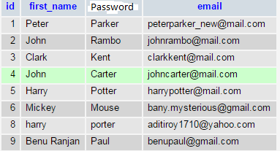

**Register User Can Login:** If username password wrong show error messages.

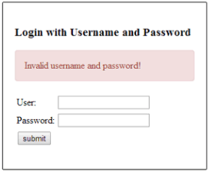

**User Login Successful:** If username password correct go to success page.

